‘PIGSKIN PICK EM’
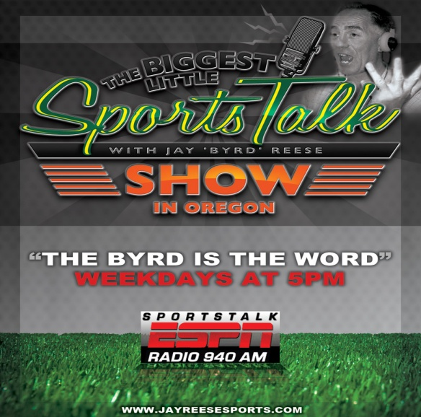SEATTLE SEAHAWKS FLYAWAY

ESPN RADIO 940-AM
PIGSKIN PICK EM-SEATTLE SEAHAWKS FLYAWAY CONTEST RULES
1. No purchase necessary, must be 21 years of age. Limit 1 entry per contestant per week for term of contest Oct. 8-Dec.12, 2012
2. Weekly entries valid Monday 5p. with entry deadline Thursday 6p.
3. Weekly winner is determined by person who has most correct game winning picks, and, or the combination of most correct picks, plus a correct Tiebreaker score, or closest combined score of Tiebreaker game without going over the actual point total.
4. Weekly winners are not eligible to re-enter contest. Weekly winners automatically qualify for the Grand Prize drawing on Dec. 12, 2012.
5. Employees, agents, or representatives of participating sponsors, Jay Reese Sports, or The Bend Radio Group are NOT eligible to participate, or win.
6. Grand Prize includes roundtrip airfare for 2 from Redmond to Seattle; 1 night Lodging at Sea-Tacoma Marriott; Dinner for 2, Limo to and from the game, and 2 game tickets on December 23, 2012 Seattle vs. San Francisco.
7. Jay Reese Sports reserves the right to change contest rules and prizes at any time.
8. All contestants and winners agree to hold Jay Reese, and Jay Reese Sports, and it’s associated Sponsors, and The Bend Radio Group harmless of any legal action as a result of this contest.
9. Winner is responsible for all taxes, fees, and liabilities.
FOR MORE INFORMATION VISIT www.jayreeseports.com & LISTEN AT 5P TO ESPN 940

